**US_296080_Cognizant: Enhance BCM to be brand aware**

**Understanding of the requirement**

BCM is enhanced with multiple brands feature.

**Assumptions**:

* UI will be providing brand value along with the ucid as the unique value to initiate all the services in BCM

**High level Technical design and solution**

* 1. Impacted Modules

BCM Modules

* 1. Impacted Workflows
     1. Overview:

Once the tenant user has been created at RentTrack, Customer details along with brand will be stored in BCM database.

BCM will validate the ucid and brand as composite for unique identification

BCM will allow for different plan names and promotion codes based on user brand

* + 1. APIs Modified to:

POST /buildcredit/customer/{ucid}/{brand}/v1

POST /buildcredit/customer/lease/{ucid}/{brand}/v1

GET /buildcredit/customer/lease/{ucid}/{brand}/v1

POST /buildcredit/customer/payment_account/{ucid}/{brand}/v1

POST /buildcredit/customer/subscription/{ucid}/{brand}/v1

* + 1. Messaging Infrastructure: N/A
    2. UI Screens: N/A
  1. DB Changes:

1. Table Name : customer_data

Brand column has been included in customer_data

Table Description :

* ucid
* customer_email
* created_date
* modified_date
* access_token
* refresh_token
* token_expiry
* token_created_date
* **brand**

2. Table Name : WebService_logs

Brand column has been included in WebService_logs

Table Description:

* id
* ucid
* **brand**
* http_status_code
* request_payload
* url
* response_payload
* http_method
* created_date
* modified_date
  1. Dependencies

BCM API

* 1. Blocker Inputs needed

N /A

* 1. Design Patterns considered and the chosen one

N/A

g) ER Diagram:

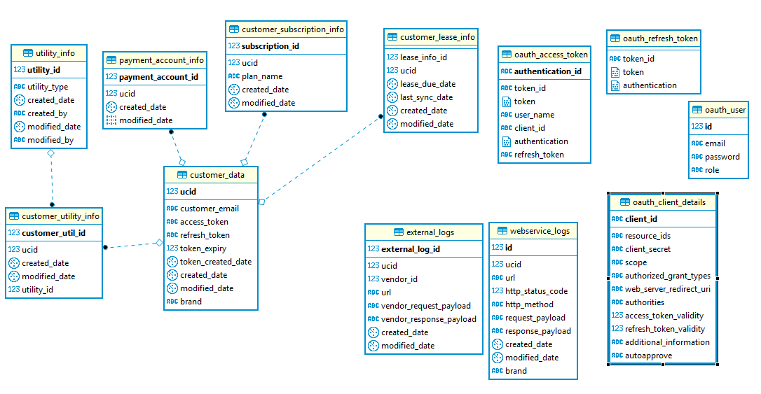

**Business** :

UI will provide ucid and brand for each call to BCM.

BCM will identify the user data based on ucid and brand as composite key value.

BCM will allow plan names and promotion codes based on the user brand.

Since Rent Track allows user’s uniqueness by email id, BCM will support only for the email id, ucid and brand as composite key for the Rent Track subscription.

**Clarifications**:

**Code / Framework References**

**Misc:**